## Q16- Write a command to give write permission to all the users of file reginfo

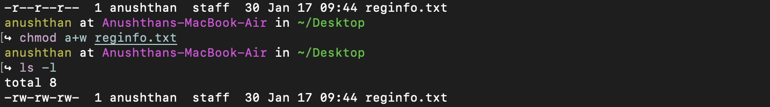

## Q17- Write a command to discard write permission from group users of file reginfo

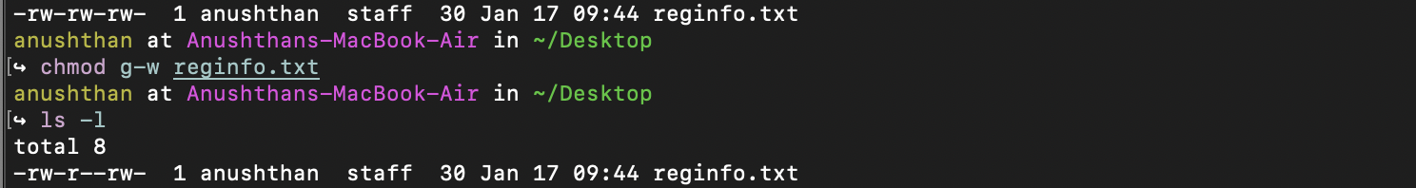

## Q18**-** Write the command to set rwx permissions for all the users of file reginfo

